Village of Kirkland

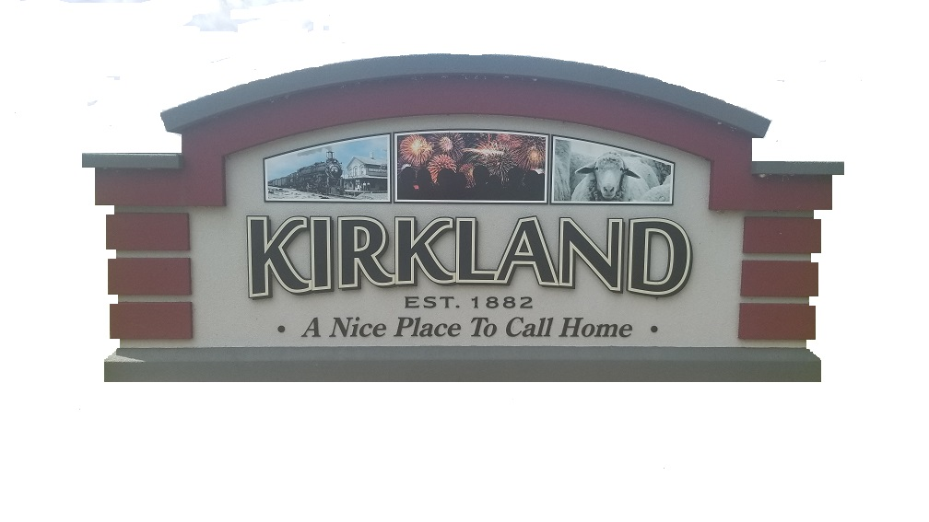

511 W. Main St. ∙ P.O. Box 550

Kirkland, Illinois 60146

Phone: (815) 522-6179

**Village of Kirkland COVID-19 Informational Update: *20 March 2020***

As some residents may have heard, the State of Illinois and Governor J.B. Pritzker have issued a “Stay at Home” Order effective at 5:00 P.M. on Saturday, March 21, 2020 and will continue thru Tuesday, April 7, 2020. All non-essential businesses must cease activities while all essential business may continue services. Essential Businesses include Grocery Stores, Gas Stations, Health Care facilities (Pharmacies, Doctors, Immediate Care Facilities, Hospitals, etc.), Banks and Post Offices to name a few. In addition, those individuals who are employed by these essential businesses are still allowed to work at their facilities, while all those employed by non-essential businesses are asked to stay home and/or work remotely. In addition, the closure of Hiawatha CUSD #426 will also be in place to April 7th, 2020. Any increases to the timeframe of this “Stay at Home” Order for Illinois and Kirkland residents will be communicated as soon as we receive the information.

The Village of Kirkland encourages residents to use the DeKalb County Health Department as a resource or contact the Illinois Coronavirus Hotline at 1 (800) 889-3931 with any questions or concerns. As of today, Friday, March 20th, there are still no cases of COVID-19 reported in DeKalb County. However, the overall cases have increased to 485 cases for Illinois with 5 reported deaths from COVID-19. This “Stay at Home” Order is aimed to minimize the rapidly increasing cases we are seeing with COVID-19 in the State of Illinois.

The Village of Kirkland will continue to participate in the daily updates provided to us by the State of Illinois and Illinois Governor’s office. All relevant information or updates will be shared with our residents. As previously mentioned, Kirkland Village Hall is closed and this closure will now continue thru Tuesday, April 7, 2020. We will still have staff in place between the Village, Kirkland Police Department and Kirkland Public Works to ensure all essential tasks, jobs and responsibilities are completed. Anyone with questions can call Kirkland Village Hall at (815) 522-6179.

**Waste Management Garbage / Recycling Collection**

The following information has been provided to the Village of Kirkland this week from Waste Management with regards to its Garbage and Recycling Services:

* Effective March 18, 2020, we are temporarily closing residential call centers to help prevent the spread of the coronavirus (COVID-19).
* We are actively coordinating remote operations to serve our customers during this situation with the goal of resuming residential call handing as soon as possible.
* At this time, there is no impact to your scheduled residential collection service.

Effective immediately the following changes are being implemented until further notice:

* ***Bulky item collection -*** *including scheduled events or extra call in service for bulky items, such as large items outside the cart, is suspended until further notice. This includes white good pickup.*

Therefore, all garbage and recycling from residents MUST be place ONLY in Waste Management Garbage and Recycling bins. NO GARBAGE is allowed to be placed outside of the issued bins. It is also a violation of Village Ordinance to leave garbage at the curb more than 24 hours prior to or after collection, so please ensure this ordinance is followed.

Thanks!

* Village of Kirkland