Village of Kirkland

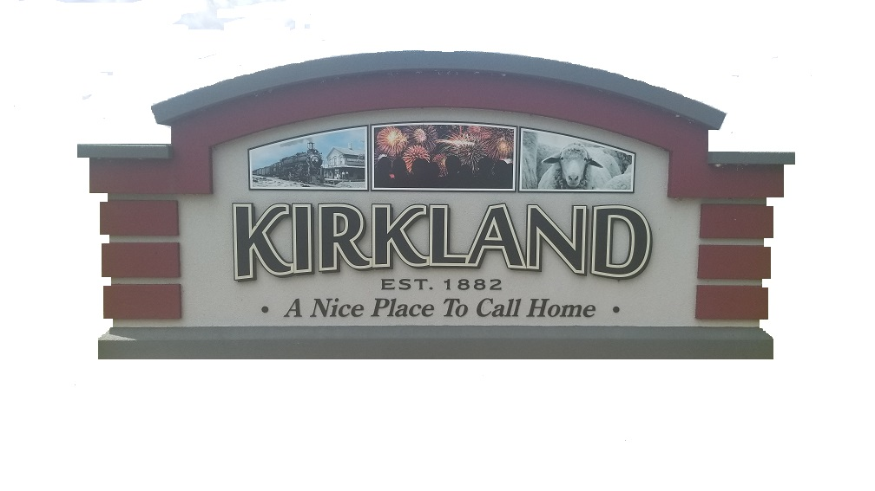

511 W. Main St. ∙ P.O. Box 550

Kirkland, Illinois 60146

Phone: (815) 522-6179

**Village of Kirkland COVID-19 Informational Update: *31 March 2020***

Today, Tuesday, March 31st, the State of Illinois and Governor J.B. Pritzker have decided to extend the current “Stay at Home” Order thru Thursday, April 30th, 2020. All non-essential businesses must continue to cease activities while all essential business may continue services. Essential Businesses include Grocery Stores, Gas Stations, Health Care facilities (Pharmacies, Doctors, Immediate Care Facilities, Hospitals, etc.), Banks and Post Offices to name a few. In addition, those individuals who are employed by these essential businesses are still allowed to work at their facilities, while all those employed by non-essential businesses are asked to stay home and/or work remotely. In addition, the closure of Hiawatha CUSD #426 will also be in effect thru Thursday, April 30th, 2020 and Remote Learning will be in effect until classes resume. Any changes in duration of the “Stay at Home” Order will be communicated as soon as they are received.

The Village of Kirkland encourages residents to use the DeKalb County Health Department as a resource or contact the Illinois Coronavirus Hotline at 1 (800) 889-3931 with any questions or concerns. As of today, Tuesday, March 31st, 2020, there are a total of 11 COVID-19 cases reported in DeKalb County. In addition, the overall cases for the State of Illinois has increased to 5,994 cases and 99 reported deaths from COVID-19. This “Stay at Home” Order is aimed to minimize the rapidly increasing cases we are seeing with COVID-19 in the State of Illinois.

The Village of Kirkland will continue to participate in the daily updates provided to us by the State of Illinois and Illinois Governor’s office. All relevant information or updates will be shared with our residents. Kirkland Village Hall will remain closed thru April 30th, 2020 to comply with “Social Distancing” requests from local and State officials. We will continue to have staff in place between Village administration, Kirkland Police Department and Kirkland Public Works to ensure all essential tasks, jobs and responsibilities are completed. Anyone with questions can call Kirkland Village Hall at (815) 522-6179.

**Village of Kirkland Board Meeting for April 2020**

As of today, we will still plan to hold the Village of Kirkland Board Meeting on Monday, April 20th, 2020. We are looking into a couple of options to hold the meeting:

* Teleconference Meeting which allows Board Members and General Public to call into the meeting using a teleconference number and access code. This would be an Audio Only meeting if this option is chosen.
* Regular Meeting with “Social Distancing” applied between Board Members. The General Public may be asked to provide any Public Comments to the Village of Kirkland Board prior to the start of the meeting to ensure we apply with the current, modified Open Meetings Act guidelines under current COVID-19 Executive Order.

Once a decision has been reached for our Village of Kirkland Board Meeting, we will communicate details to our residents.

Thanks!

* Village of Kirkland